King Fahd University of Petroleum and Minerals
Information and Computer Science Department

ICS 103: Computer Programming in C
Spring Semester 2006-2007 (Term-062)

Major Exam-2

Time:120 minutes Wednesday, May 2, 2007

Name:
ID#:

PLEASE CIRCLE YOUR SECTION BELOW:

Section | 1 | 2 | 3 | 4 | 5 | 6 | 7
Time | SM-8-9 | SM 9-10 | SM 11-12 | UT 9-10 | UT 11:12 | UT 8-9 | UT 10-11

Note:

- Copying or Discussion will result in zero grade for all the students involved.
- Attempt all questions.

Question # | Maximum Marks | Obtained Marks
1-1,1-2 | 2x 6 = 12
1-3,1-4 | 2x6=12
1-5,1-6,1-7 | 3x6=18
2 | 8
3 | 10
4 | 10
5 | 10
6 | 20
Total | 100

Good Luck

Question 1: (42 points=7X6)

Find the out of the following programs.
Program | Output
#include <stdio.h> // 6 points  int main() {  int x[3],y[3],i;  printf("Enter 6 integer values >");  for (i=0;i<3;i++)  scanf("%d%d",&x[i],&y[2-i]);  for(i=0;i<3;i++)  printf("%d\t%d\n",x[i],y[i]);  return 0;  }  Values typed by the user  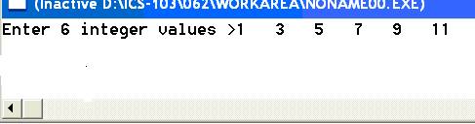 | 1 11  5 7  9 3
#include<stdio.h> // 6 points  void fill(int a[],int b[],int n){  do{  if(n%2==0)  a[n]=b[n%3]+b[n%2];  else  a[n]=b[n-1]+b[n];  ++n;  } while(n<3);  }  int main(void){  int x[3]={4,3,7};  int y[3];  fill(y,x,0);  printf("%d\t%d\t%d",y[0],y[1],y[2]);  return 0;  } | 8 7 11
#include <stdio.h> // 6 points  int main() {  int x[6]={3,2,1};  int y[6],i;  for(i=0;i<6;i++) {  if(i%3==0)  y[i]=x[i]-1;  else if(i%3==1)  y[i]=y[i-1]+2;  else  y[i]=x[i]+5;  printf("%d\t",y[i]);  }  return 0;  } | 2 4 6 -1 1 5
#include <stdio.h> // 6 points  #define SIZE 6  void test (int x[], int n) {  int i=0;  do {  x[i]=x[i]+x[n-i-1];  i++;  }while (i<n);  }  int main() {  int y[SIZE]={4,5,6,6,4,2},i;  test(y,SIZE);  for(i=0;i<SIZE;i++) {  printf("%d\t",y[i]);  }  return 0;  } | 6 9 12 18 13 8
#include <stdio.h> // 6 points  #define SIZE 6  void test (int *b, int a) {  a=a+4;  *b=*b/2+*b;  }  int main() {  int y[SIZE],i;  for(i=0;i<SIZE;i++) {  y[i]=i;  test(&y[i],y[i]);  printf("%d\t",y[i]);  }  return 0;  } | 0 1 3 4 6 7
#include <stdio.h> // 6 points  int main() {  int a=5,b=1,c;  int *p1,*p2;  p1=&a;  p2=&b;  *p2=*p1+3;  *p1=b+1;  c=a+1;  printf("a=%d, b=%d, c=%d",a,b,c);  return 0;  } | a=9 , b=8, c=10
#include <stdio.h> // 6 points  int rec (int i){  int j=0;  if (i > 2) {  printf ("%d\n",i);  j= rec(i-1) + 1;  }  else  j= i;  return j;  }  int main(void){  printf("%d\n",rec(6));  return 0;  } | 6  5  4  3  6

Question 2 : (8 points)
Questions 2,3, and 4 will deal with writing a c program to find the real roots of a quadratic equation of the form ${\text{ax}}^{2}+\text{bx}+c=0$ .
In this question you are asked to write a logical function checkabc. This function will receive the values of the coefficients a,b, and c (real values) and returns 1 in case $b^{2}−4\text{ac}≥0$. If $b^{2}−4\text{ac}<0$, it returns 0. All necessary include statements will be written in the main function only.

int checkabc (double a, double b, double c) {
if(b*b-4*a*c >=0)
return 1;
else
return 0;
}

Question 3: (10 points)
Write a function roots that will receive the values of a,b, and c and returns the values of the two roots r1 and r2 using output parameters. This function assumes that $b^{2}−4\text{ac}≥0$.
$r1=\frac{−b+\sqrt{b^{2}−4\text{ac}}}{2a}$ and $r2=\frac{−b−\sqrt{b^{2}−4\text{ac}}}{2a}$

void roots (double a, double b, double c, double *r1, double *r2) {
double delta=sqrt(b*b-4*a*c);
*r1=(-b-delta)/(2*a);
*r2=(-b+delta)/(2*a);
}

Question 4: (10 points)
Write the main function to do the following:
- ask the user to enter the values of a,b, and c.
- If the equation has real roots (check by calling the function checkabc), call the function roots, then display the values of the roots. Otherwise, display a message saying “Sorry no real roots for a,b, and c values typed”.

The following are 2 examples of executing the program.
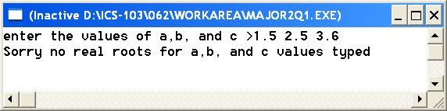
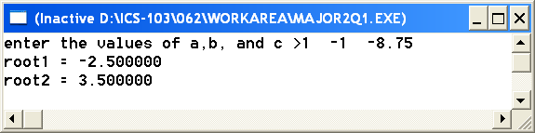

#include <stdio.h>
#include <math.h>
int main() {
double a,b,c,root1,root2;
printf("enter the values of a,b, and c >");
scanf("%lf%lf%lf",&a,&b,&c);
if(validateRoots(a,b,c)==1) {
roots(a,b,c,&root1,&root2);
printf("root1 = %lf\n",root1);
printf("root2 = %lf\n",root2);
}
else
printf("Sorry no real roots for a,b, and c values typed ");
return 0;
}
Question 5 : (10 points) :
Write a logical function perfsquare that will receive an integer number
and returns 1 if it is a perfect square, 0 otherwise.
16, 25, 36, and 49 are examples of perfect squares.

#include <math.h>
int psquare (int n) {
int i=sqrt(n); // assuming that n is positive
if(i*i==n) // or i==sqrt(n)
return 1;
else
return 0;
}

Question 6: (20 points)
Write a c program that reads 30 positive integer numbers from a file “input.txt”. For each value read; the program checks if it is a perfect square or not by calling the logical function perfsquare (question 5). If the value is a perfect square, it is assigned to array psquarenb, otherwise it will be assigned to array notsquarenb. Each of the two arrays psquarenb and notsquarenb will be declared with a size of 30(to be defined as a constant). After finishing reading from the file, your program will write the values in the two arrays in the file “output.txt” showing how many perfect square numbers found and their values. Also how many numbers found that are not perfect square.
Note: Even if you have not solved Question 5, assume that the function perfsquare exists.

An example of executing your program with the following input file “input.txt”
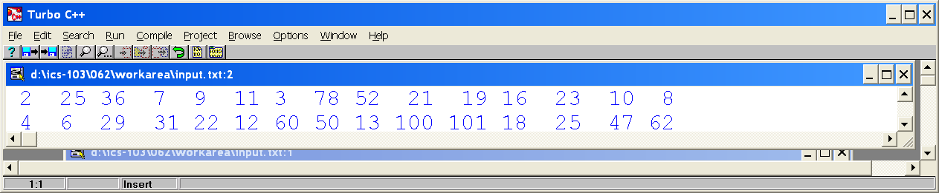
Will give the following Output file “output.txt”
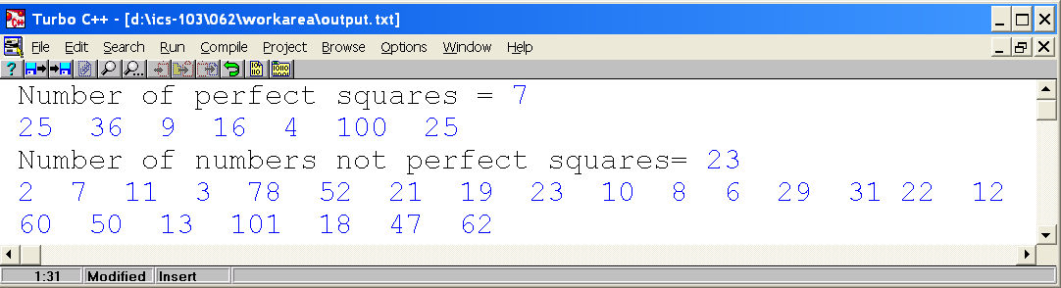

#include <stdio.h>
#include <math.h>
#define SIZE 30
int main() {
int squarenb[SIZE],notsquarenb[SIZE];
FILE *inp,*out;
int countsq=0,countnotsq=0,i,number;
inp=fopen("input.txt","r");
out=fopen("output.txt","w");
for(i=0;i<SIZE;i++) {
fscanf(inp,"%d",&number);
if(psquare(number)==1) {
squarenb[countsq]=number;
countsq++;
}
else {
notsquarenb[countnotsq]=number;
countnotsq++;
}
}
fprintf(out,"Number of perfect squares = %d\n",countsq);
for(i=0;i<countsq;i++)
fprintf(out,"%d ",squarenb[i]);
fprintf(out,"\nNumber of numbers not perfect squares= %d\n",countnotsq);
for(i=0;i<countnotsq;i++)
fprintf(out,"%d ",notsquarenb[i]);
fclose(out);
fclose(inp);
return 0;
}

